**EduHome**

**INDEX**

|  |  |  |
| --- | --- | --- |
| **Sr.**  **No.** |  | **Contents** |
| **1** |  | **Planning** |
|  | **1.1** | Synopsis |
|  | **1.2** | Work Breakdown Structure |
|  | **1.3** | PERT CHART |
|  | **1.4** | GANTT CHART |
|  | **1.5** | Methodology |
|  | **1.6** | Model Used |
| **2** |  | **Analysis** |
|  | **2.1** | Client Profile |
|  | **2.2** | Domain Analysis |
|  | **2.3** | Requirement Gathering |
|  | **2.4** | Software Requirement Specification |
|  | **2.5** | Feasibility Study |
|  | **2.6** | Cost Benefit Analysis |
| **3** |  | **Design** |
|  | **3.1** | **Physical Design** |
|  | 3.1.1 | System Flow Chart |
|  | **3.2** | **Logical Design** |

|  |  |  |  |
| --- | --- | --- | --- |
|  | 3.2.1 | Use case Diagram |  |
|  | 3.2.2 | Sequence Diagram |  |
|  | 3.2.3 | Activity Diagram |  |
|  | 3.2.4 | State Diagram |  |
|  | 3.2.5 | Process Flow Chart |  |
|  | **3.3** | **Work/Data Flow** |  |
|  | 3.3.1 | ER Diagram |  |
| **4** |  | **Implementation** |  |
|  | 4.1 | Sample Screenshots |  |
| **5** |  | **Testing** |  |
|  | **5.1** | **Unit Testing** |  |
|  | 5.1.1 | Test Considerations |  |
|  | 5.1.2 | Test strategies |  |
|  | 5.1.3 | Test cases |  |
| **6** |  | **Maintenance** |  |
|  | 6.1 | FAQ |  |
|  | 6.2 | User Manual |  |
| **7** |  | **Annexure** |  |
|  | 7.1 | Data Dictionary |  |
|  | 7.2 | References/Bibliography |  |

**PLANNING**

## SYNOPSIS

## Objectives:

To create platform where any users can opt for different courses, purchase books for learning and by taking quiz for learning exercise.

## Project Description:

The online classroom is a very popular platform for the education system. Many countries are now enforcing the online classroom system so that the teachers and students can communicate with each other. For example, a very common and known to all ‘Google Classroom’. This online classroom system provides many facilities like shared materials, assignments, grade students, create unlimited courses, add students in there, etc. This is a great opportunity for every educational institute to enlarge and ease their education system. After the covid-19 breakdown, most of the educational institutes all around the world went into the online classroom system. They are using many online classroom platforms like ‘TalentLMS’,’ Google Classroom’, ‘visme’, etc. So, we have got the motivation to make this online classroom system for teachers and students. Our Eduhome online classroom system has some similar features like ‘google classroom’ but we have added some different features to it. Also, our classroom had some extra features that can help the teachers to teach their students more efficiently. Our Eduhome online classroom provides some facilities that can be highly mentioned. We have made a whiteboard feature where a teacher can easily draw so that she/he can teach the students more understandably. Also, our system provides an opportunity to see how many students are online in a specific class whenever a teacher creates a class according to the schedule. Also, in the scheduled class, the teacher and students can get a feature where they could start conversations. So, our EduHome online system has some significant facilities that a teacher or a student can utilize for their educational purpose.

## Problems face by client(existing system):

After the covid-19 breakdown, most of the educational institutes all around the world went into the online classroom system. They are using many online classroom platforms like ‘TalentLMS’,’ Google Classroom’, ‘visme’, etc. So, we client got the motivation to make this online classroom system for teachers and students.

## How Web Application has solution:

To provide distance learning and To make it convenient for people who have other commitments

## Functionality/feature of new/proposed system:

Following social distancing, user can opt for different courses online and purchase books online.

## Work Breakdown Structure (WBS)

A complex work project is made manageable by first breaking it down into individual components in a hierarchical structure, known as the Work Breakdown Structure, or the WBS. Such a structure defines tasks that can be completed independently of other tasks, facilitating resource allocation, assignment of responsibilities, and measurement and control of the project. Some widely used reasons for creating a WBS include:

* Assists with accurate project organization
* Helps with assigning responsibilities
* Shows the control points and project milestones
* Allows for more accurate estimation of cost, risk and time
* Helps explain the project scope to stakeholders

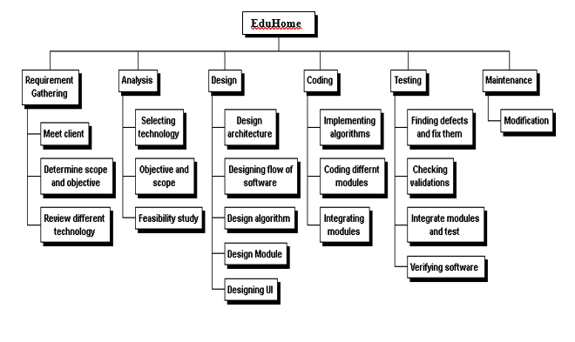

## PERT CHART

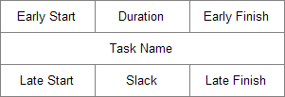Program Evaluation Review Technique, commonly known as PERT is a project management tool that provides a graphical representation of a project's timeline. A PERT chart is a graph that represents all of the tasks necessary to a project's completion, and the order in which they must be completed along with the corresponding time requirements.

**Each node represents some information:**

* Earliest start time for the task
* Duration required completing a task of work
* Earliest finish time for the task
* Descriptive information about the task
* Latest start time for the task
* Time available for a task before it must begin or finish so that it will not affect the project completion time
* Latest finish time for the task

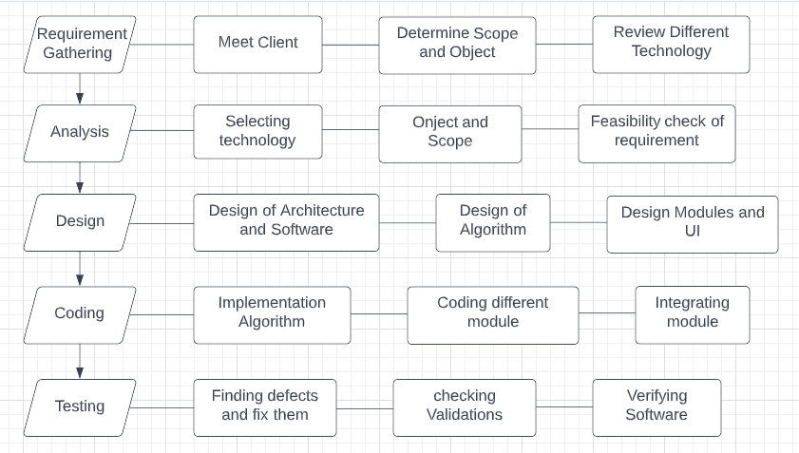

## Gantt Chart

A Gantt chart is a type of bar chart, developed by Henry Gantt in the 1910s, that illustrates a project schedule. Gantt chart illustrates the start and finish dates of the terminal elements and summary elements of a project. Modern Gantt chart also shows the dependency (i.e., precedence network) relationship between activities.

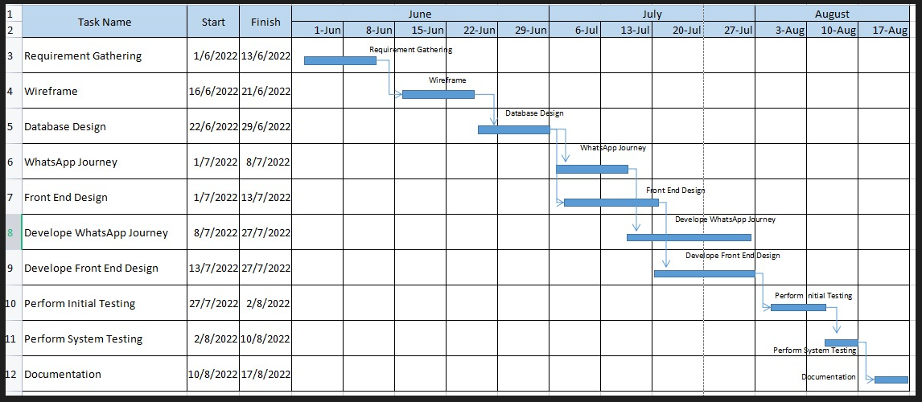

## Methodology

There are two types of methodologies:

1. Object Oriented Analysis and Design (OOSAD)
2. Structure System Analysis and Design (SSAD)

The **OOSAD** approach recommends an analysis of domain and organization business and builds object models of entities and processes independent of the system under consideration.

The **OOSAD** principle is that when an object is available for use in current, proposed and futuristic systems. **OOSAD** claims that development efficiency is higher and costs of development are lower.

When requirements are crystal clear to user, we use **Structure System Analysis and Design**.

In **Evolutionary Development methodology** steps are namely requirement analysis, design, coding, testing and implementation.

Evolutionary Development Methodology is a combination of iterative and incremental approach to software development. Delivering a system in a big bang release, delivering it in incremental process over time is the action done in this methodology. Some initial requirements and architecture envisioning need to be done.

The Evolutionary Development Methodology divides the development cycle into smaller incremental waterfall models in which users are able to get access to the product at the end of each cycle. Evolutionary Development Methodology suggests breaking down of work into smaller chunks , Prioritizing them and then delivering those chunks to the customer one by one. The main advantage is that customer's confidence increases as he constantly gets deliverables from the begining of the project to verify and validate his requirements.

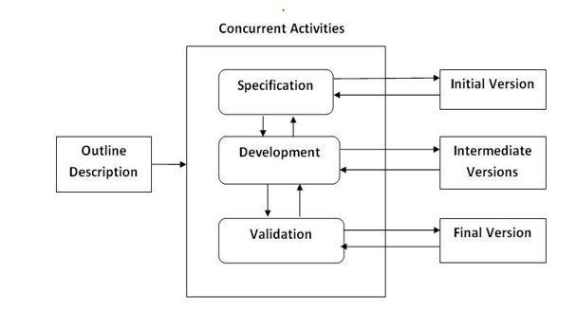

## Process model

**There are five process models of Evolutionary Development methodology:**

1. Iterative/Incremental Model
2. Prototype Model
3. Rapid Application Development (RAD)
4. Spiral
5. Boehm Spiral

We have chosen to use incremental model, the Software Development Life Cycles Models to develop our software.

The incremental model is a method of software development where the model is designed, implemented and tested incrementally. The product is defined as finished when it satisfies all of its requirements. This model combines elements of waterfall model with iterative philosophy of prototyping.

The product is decomposed into a number of components, each of which are designed and built separately. Each component is delivered to client when it is complete. This model of development also helps ease the traumatic effect of introducing completely new system all at once.

It generates working software quickly and early during software life cycle. It is more flexible-less costly to test and debugging a smaller iteration. Each iteration is an easily managed milestone. Easier to manage risk because risk piece are identified and handled during its iteration.

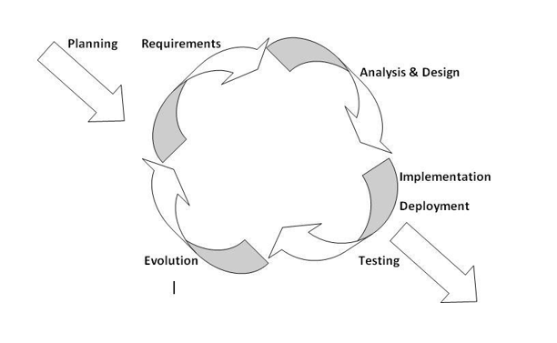

# **ANALYSIS**

## Client Profile



Our client is the Focus Stack company wants to design a website for various courses in different programming languages and different Areas.

After the covid-19 breakdown, most of the educational institutes all around the world went into the online classroom system. They are using many online classroom platforms like ‘TalentLMS’,’ Google Classroom’, ‘visme’, etc. So, we have got the motivation to make this online classroom system for teachers and students.

## Domain Analysis

Through our domain analysis we came to know that clients require an automated system for the work that they carry out manually in which it includes a lot of paper work which leads to human mistakes and misunderstanding also there is a no proper way or means of keeping track of entire work process being carried out. So they need a software developer to develop a system for them which will ease their work and automate it with less manual mistakes been recorded. So, the client required a place where they could find developers for their work, whom they would hire for their project, who would work to meet their requirements within the specified time schedule and budget with some negotiation between both of them.

## Requirement Gathering

## Existing System

During and after COVID-19, several different problems are faced by teachers/organizations as well as students:

Manual work

Time consuming

Difficult to manage

High chances of misplacing answer sheets

## New System

To overcome these problems, our software provides the basic solutions which are:

No manual work is required

Results are generated on the spot, so no need of paper work and consumes very less amount of time

No loss of data

Efficient and accurate

## Functionality or Features of new system

Automate question paper generation with their respective subject

On the spot results will be generated

Admin can add or delete or active new subjects

Admin can add or delete or active questions related to subject

User can buy books after registering to website

## Specification:

Software:

Frontend: HTML, CSS, JavaScript, Bootstrap.

Backend: PHP

Database: MySQL.

Server: Apache Tomcat

## Software Requirement Specification

**Aim:** To decide the system requirement study our project with necessary illustrations and following the standards.

**Objective:** EduHome main objective is to provide knowledge hub and online course on different subjects and user can purchase books.

**Introduction:** EduHome is the knowledge hub and online portal for online courses. It requires information regarding different programming languages/subjects on which user can opt for and learn them with mentioned notes or by purchasing available books for same. The project is Web application so it’s independent of any Operating System.

Interfaces includes following module:

1. Courses
2. Login
3. Register
4. Contact Us
5. Book-Shop

**Purpose:** To create platform where any users can opt for different courses, purchase books for learning and by taking quiz for learning exercise.

**Scope:** The scope of the project is mainly to provide many features:

* To maintain details of courses, student, question paper and allow users to purchase books.
* To allow user check course details only if they registered and logged in.
* To learn and exercise different subjects – exercise quiz is available.
* To provide login facilities to students/users.

**Overall Description:**

The newly developed system will be invoked mainly when:

User want to learn different subjects via online.

User want to purchase books regarding different subjects/topics.

Want to know about site

* Interface with About Us:

When user want to know about our project, they can see actual purpose of our site.

* Interface with Login:

When a login user can see the tabs such as Home, Course, Book-Shop and FAQ. User will select or click on their desired option. He/she can manage account details, enrol for any available courses, get information regarding that selected course, take up exercise quiz for learning and purchase books as per their requirement.

* Interface with Register:

When a user wants to learn any courses and purchase books on it then he/she can register in web application. After registering they can login on EduHome. If emailed/userID once given for registration they can’t register again with same emailID/userID.

* Interface with Contact Us:

When user has some issues then he/she can contact to the website and give comment/feedback.

**The main functions of the system are:**

To give knowledge to user regarding different courses.

To purchase books according to user requirements.

**Hardware & Software Requirement:**

|  |  |
| --- | --- |
| Client-Side Programming | Browser(HTML5/CSS3, Javascript) |
| Server-Side Programming | PHP – XAMP |
| Database Server | MySQL |

As the system engineering required object-oriented approach the software required following UML diagrams:

->Use-case diagrams

->Sequence diagrams

->Class diagrams

->Activity diagrams

## Feasibility Study

A feasibility study is an analysis of how successfully a project can be completed, accounting for factors that affect it such as economic, technological, legal and scheduling factors.

The goal of a feasibility study is to place emphasis on potential problems that could occur if a project is pursued and determine if, after all significant factors are considered, the project should be pursued.

Feasibility studies also allow a business to address where and how it will operate, potential obstacles, competition and the funding needed to get the business up and running.

## Types of feasibility study:

* + 1. Operational feasibility
    2. Technical feasibility
    3. Economical feasibility

## Operational feasibility:

Operational feasibility is dependent on human resources available for the project and involves projecting whether the system will be used if it is developed and implemented.

Operational feasibility is a measure of how well a proposed system solves the problems, and takes advantage of the opportunities identified during scope definition and how it satisfies the requirements identified in the requirements analysis phase of system development. Operational feasibility reviews the willingness of the organization to support the proposed system. This is probably the most difficult of the feasibilities to gauge.

## Technical feasibility:

A large part of determining resources has to do with assessing technical feasibility. It considers the technical requirements of the proposed project. The technical requirements are then compared to the technical capability of the organization. The systems project is considered technically feasible if the internal technical capability is sufficient to support the project requirements.

The analyst must find out whether current technical resources can be upgraded or added to in a manner that fulfills the request under consideration. This is where the expertise of system analysts is beneficial, since using their own experience and their contact with vendors they will be able to answer the question of technical feasibility.

## Economical feasibility:

Economic feasibility refers to the economics benefit of the project as a product. The project must generate greater revenue to cover the development costs.

Economic analysis could also be referred to as cost/benefit analysis. It is the most frequently used method for evaluating the effectiveness of a new system. In economic analysis the procedure is to determine the benefits and savings that are expected from a candidate system and compare them with costs. If benefits outweigh costs, then the decision is made to design and implement the system.

## Cost benefit Analysis

Cost Benefit Analysis (CBA) estimates and totals up the equivalent money value of the benefits and the cost to establish whatever the project is worth implementing. Cost Benefit Analysis (CBA) is the weighing scale approach to decision-making. All the plus points (such as cash flow and other intangible benefits) are put on one side and all the minus points (the cost and disadvantages) are put on the other side. Whichever weighs the heavier, wins.

On the minus (cost) side we have:

The cost of training for the users of the software However, on the plus (benefit) side we have

* + - * Improves business processes leading to annual cost decrease
      * Available information can help in making better decision (leading to additional cash flows)
      * Increase moral of the staff by using the state-of-the-art tools for running the business

A new system must increase income either through cost saving or by increased revenues and this is determined by Cost Benefit Analysis.

**Design**

## Physical Design

**System Flow Chart**

System flowcharts are a way of displaying how *data* flows in a system and how decisions are made to control events.

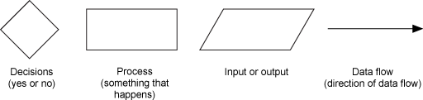To illustrate this, symbols are used. They are connected together to show what happens to data and where it goes. The basic ones include:

Symbols used in flow charts

Note that system flow charts are very similar to data flow charts. Data flow charts do not include decisions, they just show the path that data takes, where it is held, processed, and then output.

System Flow Diagram for User:

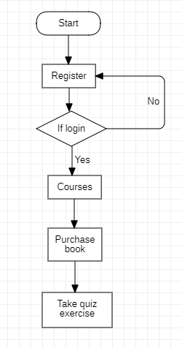

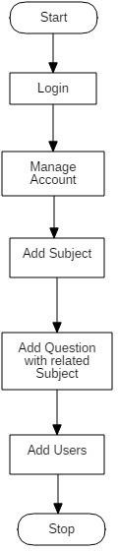System Flow Diagram for Admin:

## Logical Design

**Use case Diagram**

A use case diagram at its simplest is a representation of a user's interaction with the system and depicting the specifications of a use case. A use case diagram can portray the different types of users of a system and the various ways that they interact with the system. This type of diagram is typically used in conjunction with the textual use case and will often be accompanied by other types of diagrams as well.

To model a system the most important aspect is to capture the dynamic behavior. To clarify a bit in details, dynamic behavior means the behavior of the system when it is running /operating. So only static behavior is not sufficient to model a system rather dynamic behavior is more important than static behavior. In UML there are five diagrams available to model dynamic nature and use case diagram is one of them. Now as we have to discuss that the use case diagram is dynamic in nature there should be some internal or external factors for making the interaction. These internal and external agents are known as actors. So use case diagrams are consists of actors, use cases and their relationships. The diagram is used to model the system/subsystem of an application. A single use case diagram captures a particular functionality of a system. So to model the entire system numbers of use case diagrams are used.

The purpose of use case diagram is to capture the dynamic aspect of a system. But this definition is too generic to describe the purpose.

Because other four diagrams (activity, sequence, collaboration and State chart) are also having the same purpose. So we will look into some specific purpose which will distinguish it from other four diagrams. Use case diagrams are used to gather the requirements of a system including internal and external influences. These requirements are mostly design requirements. So when a system is analyzed to gather its functionalities use cases are prepared and actors are identified. Now when the initial task is complete use case diagrams are modelled to present the outside view.

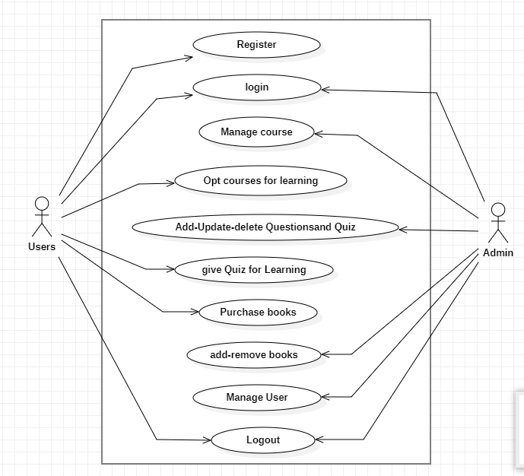

## Sequence Diagram

A sequence diagram is a diagram that shows how processes operate with one another and in what order. It is a construct of a Message. A sequence diagram shows object interactions arranged in time sequence. It depicts the objects and classes involved in the scenario and the sequence of messages exchanged between the objects needed to carry out the functionality of the scenario. Sequence diagrams are typically associated with use case realizations in the Logical View of the system under development. Sequence diagrams are sometimes called event diagrams, event scenarios.

A sequence diagram shows, as parallel vertical lines (lifelines), different processes or objects that live simultaneously, and, as horizontal arrows, the messages exchanged between them, in the order in which they occur. This allows the specification of simple runtime scenarios in a graphical manner.

The sequence diagram is used primarily to show the interactions between objects in the sequential order that those interactions occur. Much like the class diagram, developers typically think sequence diagrams were meant exclusively for them.

However, an organization's business staff can find sequence diagrams useful to communicate how the business currently works by showing how various business objects interact. Besides documenting an organization's current affairs, a business-level sequence diagram can be used as a requirements document to communicate requirements for a future system implementation. During the requirements phase of a project, analysts can take use cases to the next level by providing a more formal level of refinement. When that occurs, use cases are often refined into one or more sequence diagrams.

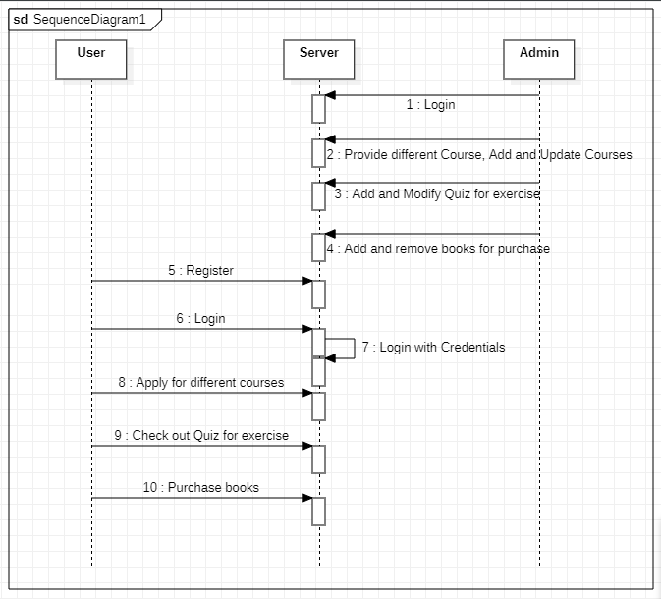

## Activity diagram

Activity diagrams are graphical representations of work flows of step wise activities and action with support for choice, iteration and concurrency. In the Unified Modeling Language, activity diagrams are intended to model both computational and organizational processes (i.e. Work flows). Activity diagrams show the overall flow of control.

Activity diagrams are constructed from a limited number of shapes, connected with arrows. The most important shape types:

* Rounded rectangles represent actions
* Diamonds represent decisions
* Bars represent the start (split) or end (join) of concurrent activities
* A black circle represents the start (initial state) of the work flow
* An encircled black circle represents the end (final state)

Activity diagram for Admin

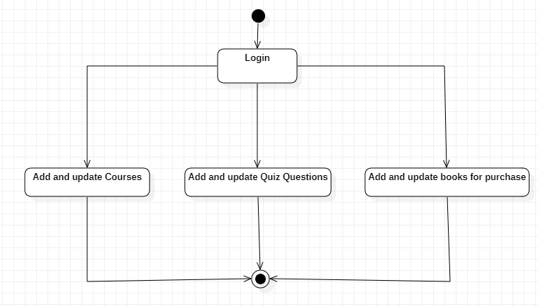

Activity diagram for User

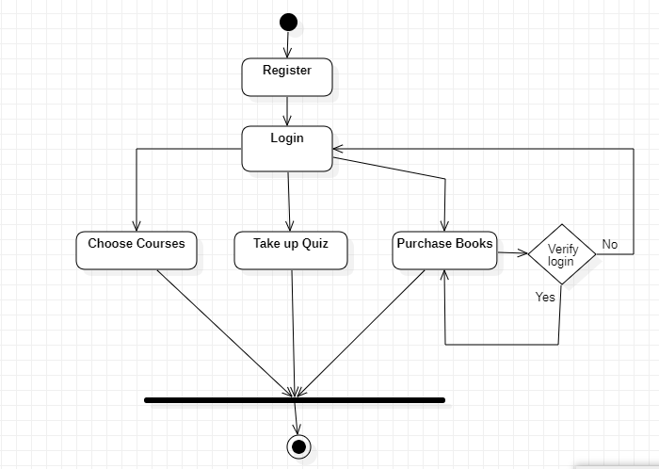

## State Diagram

A state diagram is a type of diagram used in computer science and related fields to describe the behavior of systems. State diagrams require that the system described is composed of a finite number of states; sometimes, this is indeed the case, while at other times this is a reasonable abstraction.

State Diagram of Admin:

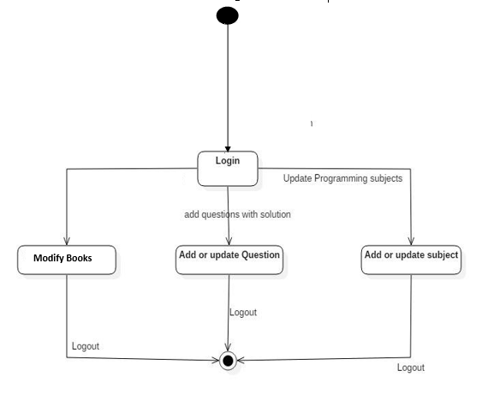

State Diagram of User

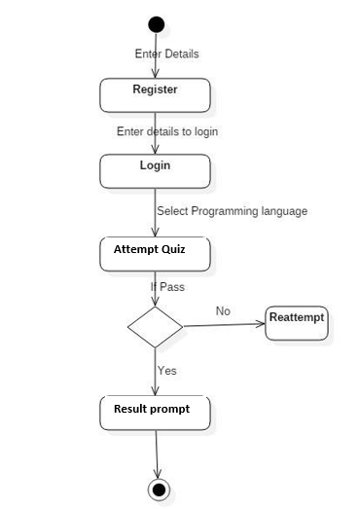

## Process Flow Chart

Also called process flowchart, process flow diagram.

A flowchart is a picture of the separate steps of a process in sequential order.

Elements that may be included are: sequence of actions, materials or services entering or leaving the process (inputs and outputs), decisions that must be made, people who become involved, time involved at each step and/or process measurements.

The process described can be anything: a manufacturing process, an administrative or service process, a project plan. This is a generic tool that can be adapted for a wide variety of purposes.

Process Flow Chart for Admin:

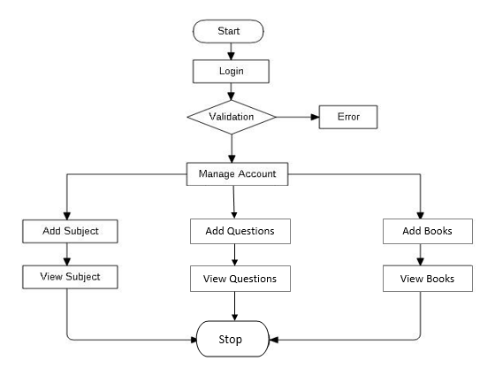

Process Flow Chart for User

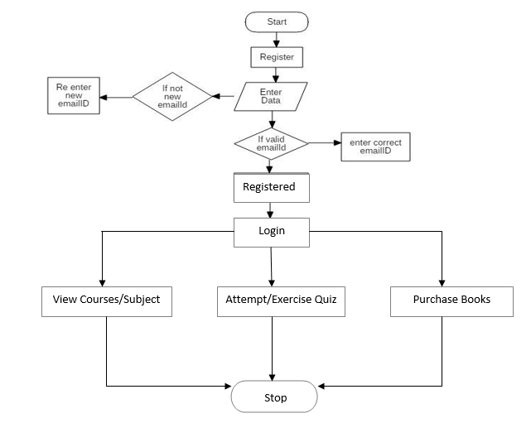

## Work/Data flow

## E-R Diagram

In software engineering, an entity–relationship model (ER model) is a data model for describing a database in an abstract way. This article refers to the techniques proposed in Peter Chen's 1976 paper.

However, variants of the idea existed previously and have been devised subsequently such as super type and subtype data entities and commonality relationships.

## Entity:

An entity may be defined as a thing which is recognized as being capable of an independent existence and which can be uniquely identified. An entity is an abstraction from the complexities of a domain. When we speak of an entity, we normally speak of some aspect of the real world which can be distinguished from other aspects of the real world. An entity may be a physical object such as a house or a car, an event such as a house sale or a car service, or a concept such as a customer transaction or order. Although the term entity is the one most commonly used, following when we should really distinguish between an entity and an entity-type. An entity-type is a category. An entity, strictly speaking, is an instance of a given entity-type.

## Relationship:

A relationship captures how entities are related to one another. Relationships can be thought of as verbs, linking two or more nouns. Examples: an owns relationship between a company and a computer, a supervises relationship between an employee and a department, a performs relationship between an artist and a song, a proved relationship between a mathematician and a theorem.

## Cardinality:

The cardinality defines the relationship between the entities in terms of numbers. An entity may be optional: for example, a sales rep could have no customers or could have one or many customers; or mandatory: for example, there must be at least one product listed in an order. There are several different types of cardinality notation; crow's foot notation, used here, is a common one. In crow's foot notation, a single bar indicates one, a double bar indicates one and only one (for example, a single instance of a product can only be stored in one warehouse), a circle indicates zero, and a crow's foot indicates many. The three main cardinal relationships are: one-to-one, expressed as 1:1; one-to-many, expressed as 1: M; and many-to-many, expressed as M: M. every entity (unless it is a weak entity) must have a minimal set of uniquely identifying attributes, which is called the entity's primary key.

Entity–relationship diagrams don't show single entities or single instances of relations. Rather, they show entity sets and relationship sets. Example: a particular song is an entity. The collection of all songs in a database is an entity set.

**E-R Diagram**

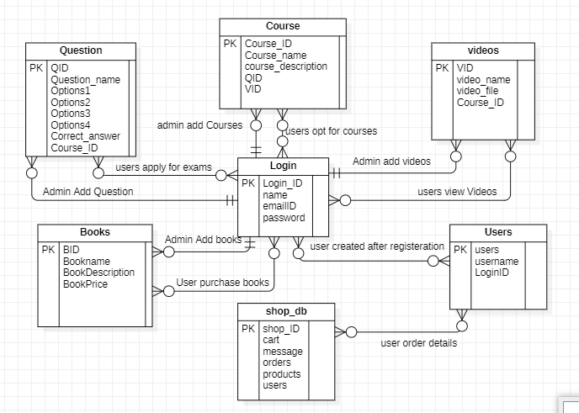

**Implementation**

## Screen shot

**Login Page:**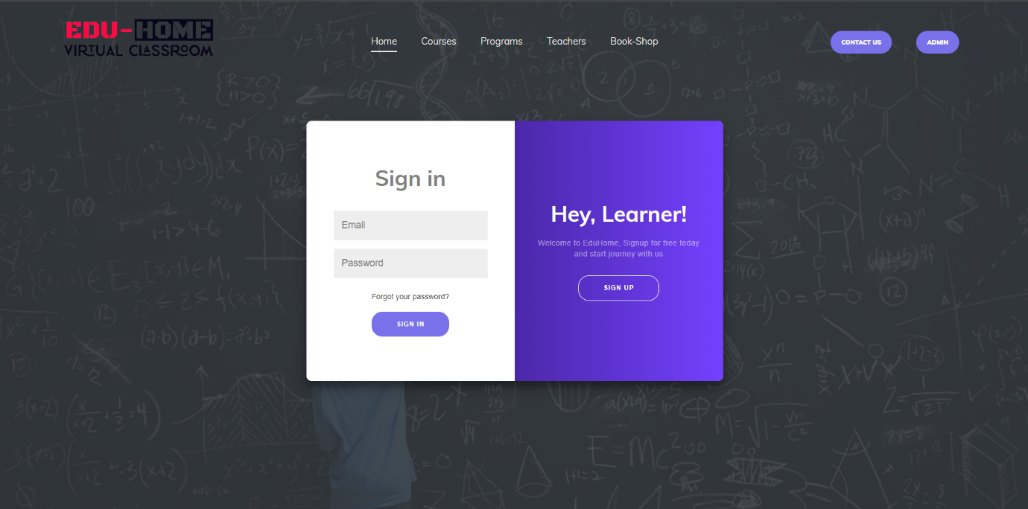

**Course details without Login:**

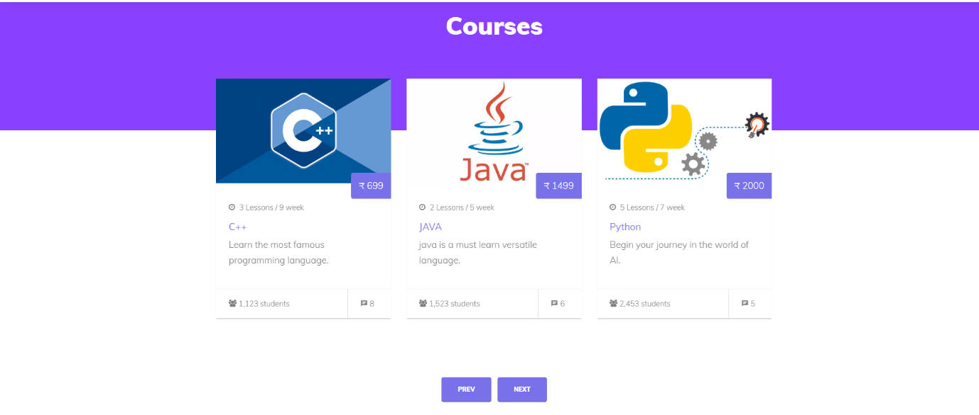

**Book Shop Page:**

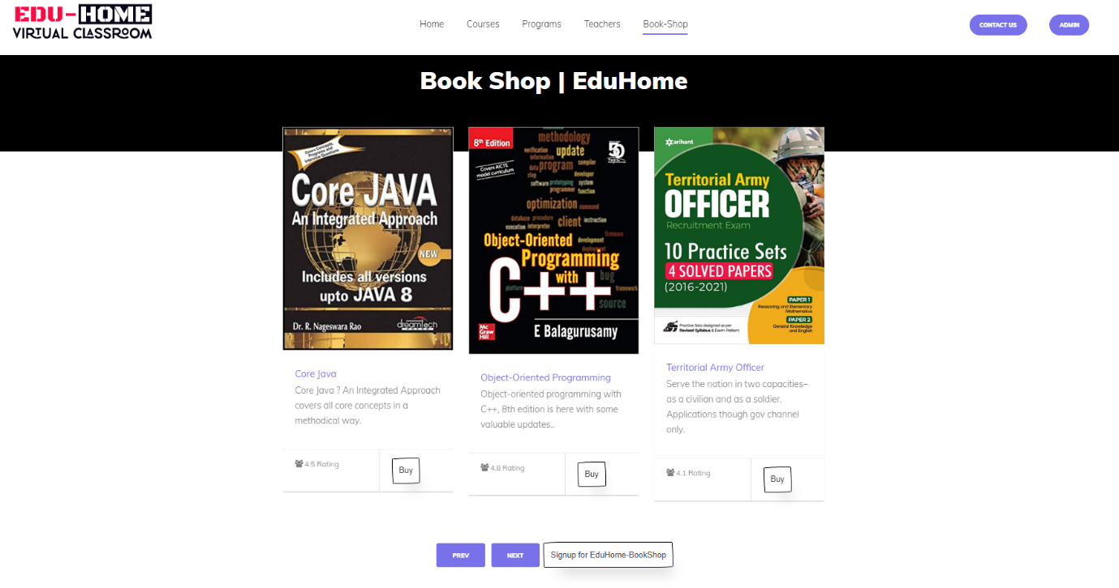

**Contact Us Page**

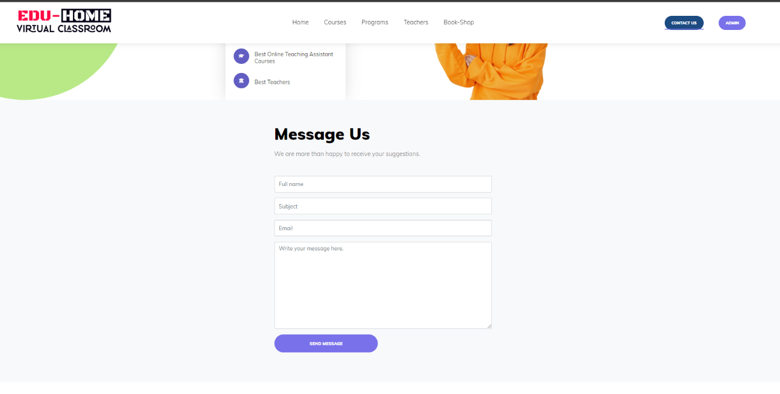

**Login Page in book Store:**

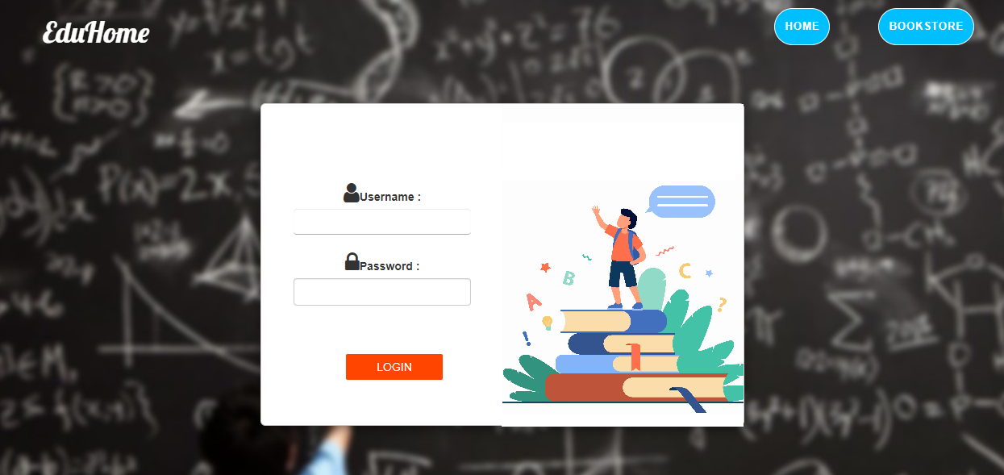

**Home Page After Login:**



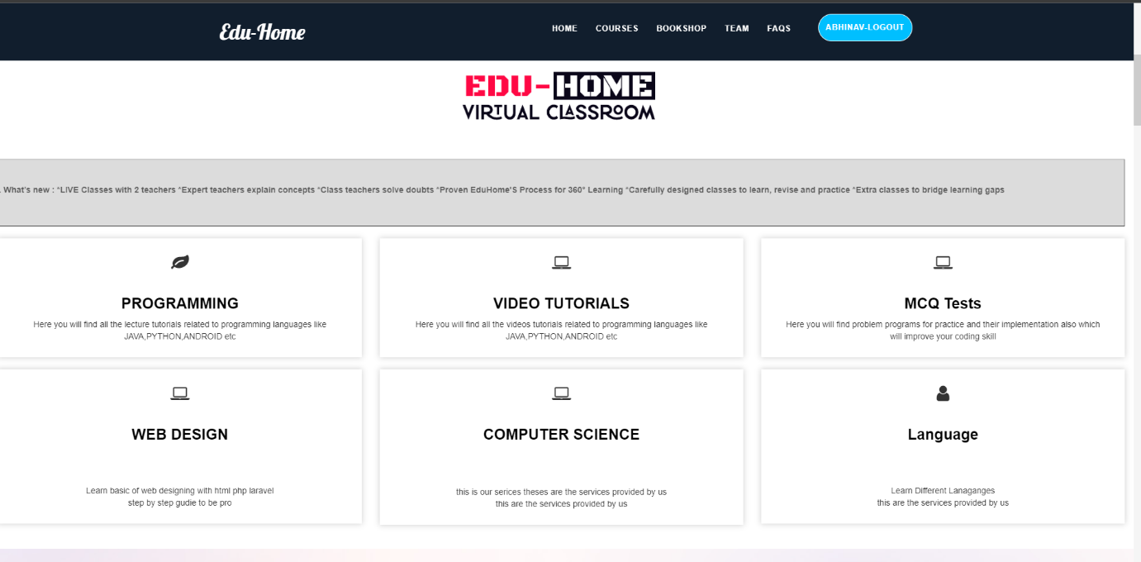

**Course Page:**



**Videos for Courses:**

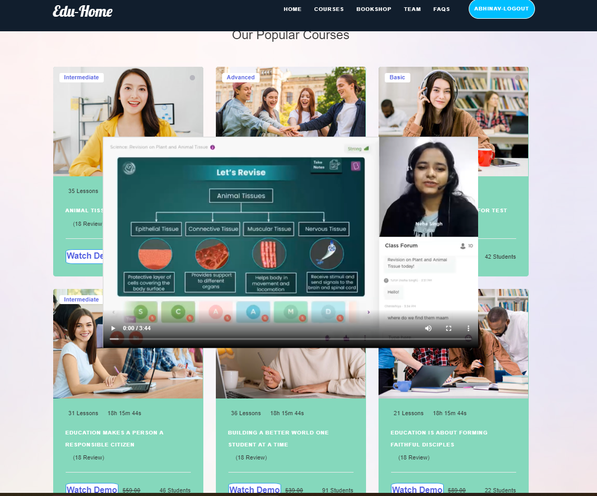

**Book Shop:**

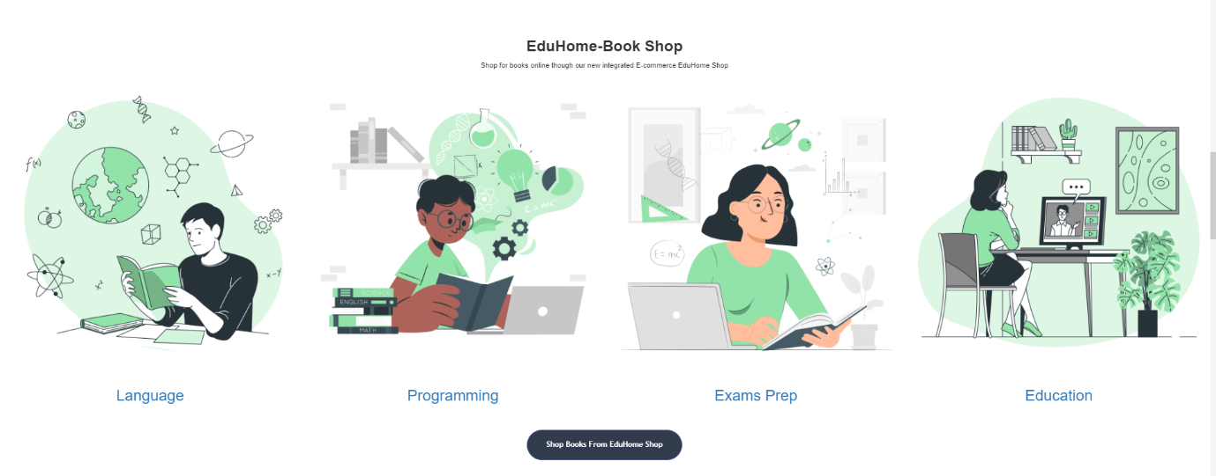

**Video Page:**

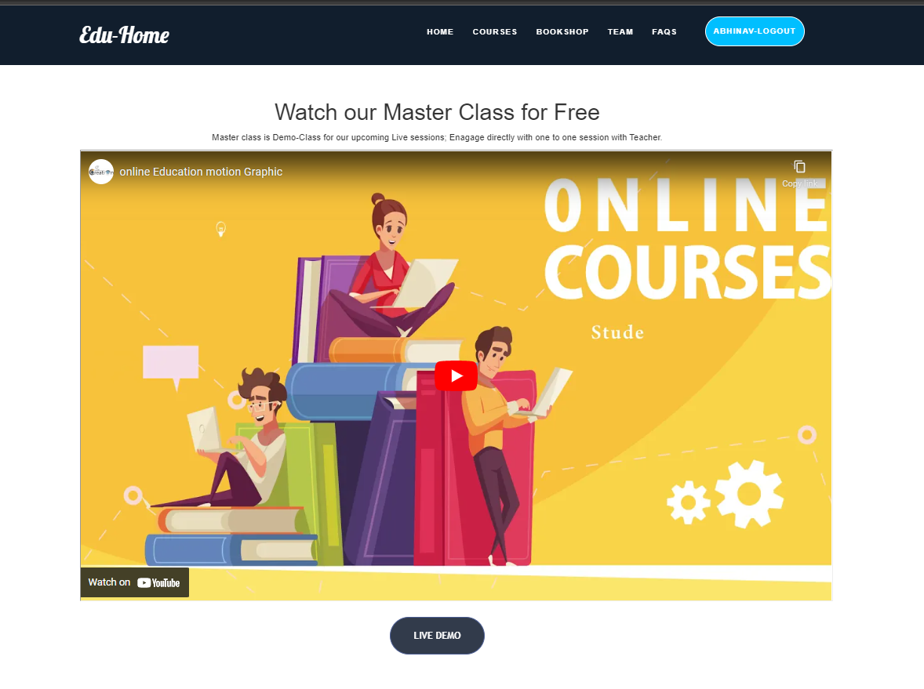

**Books in Book Store Page:**

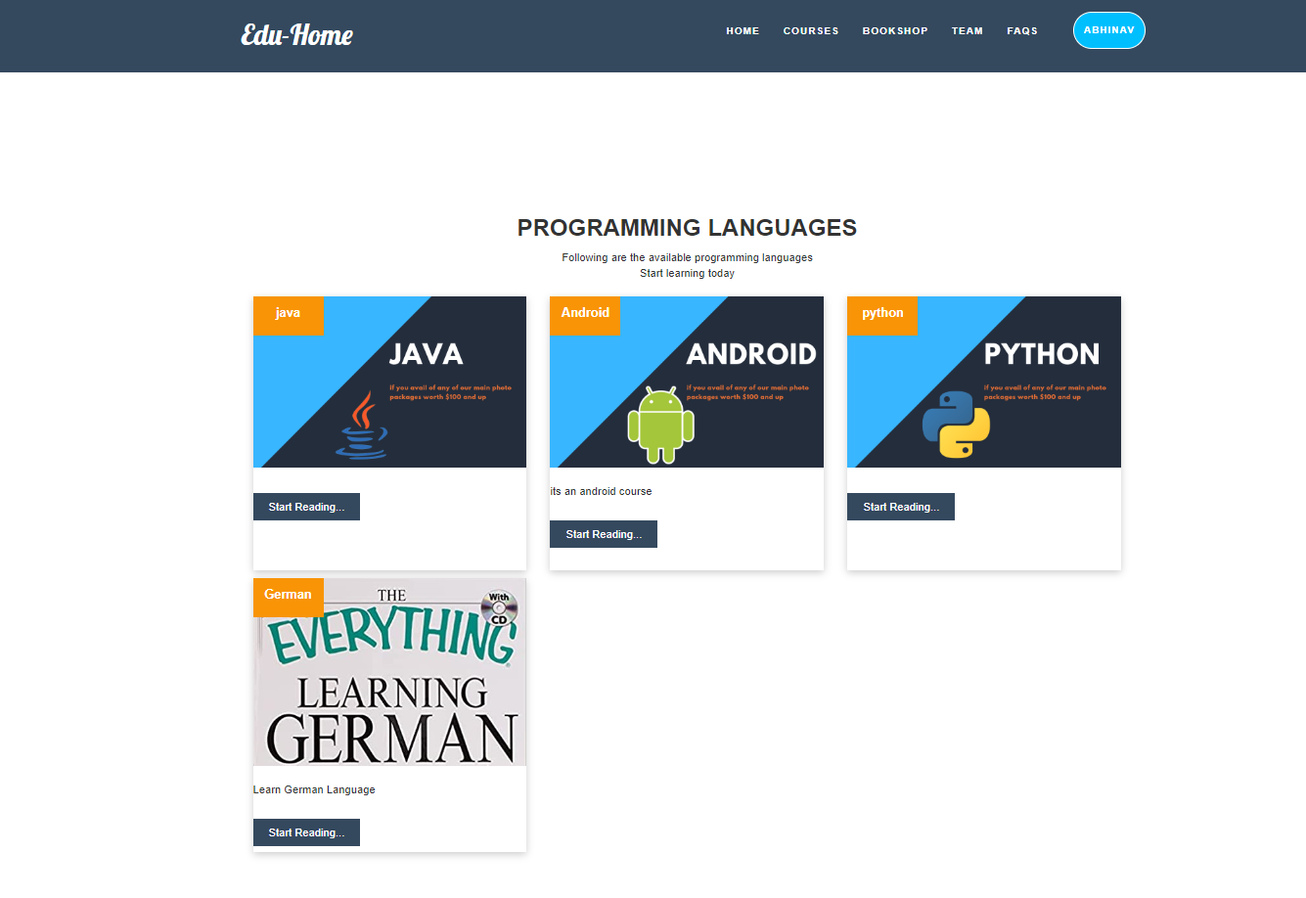

**Course details if select any one:**

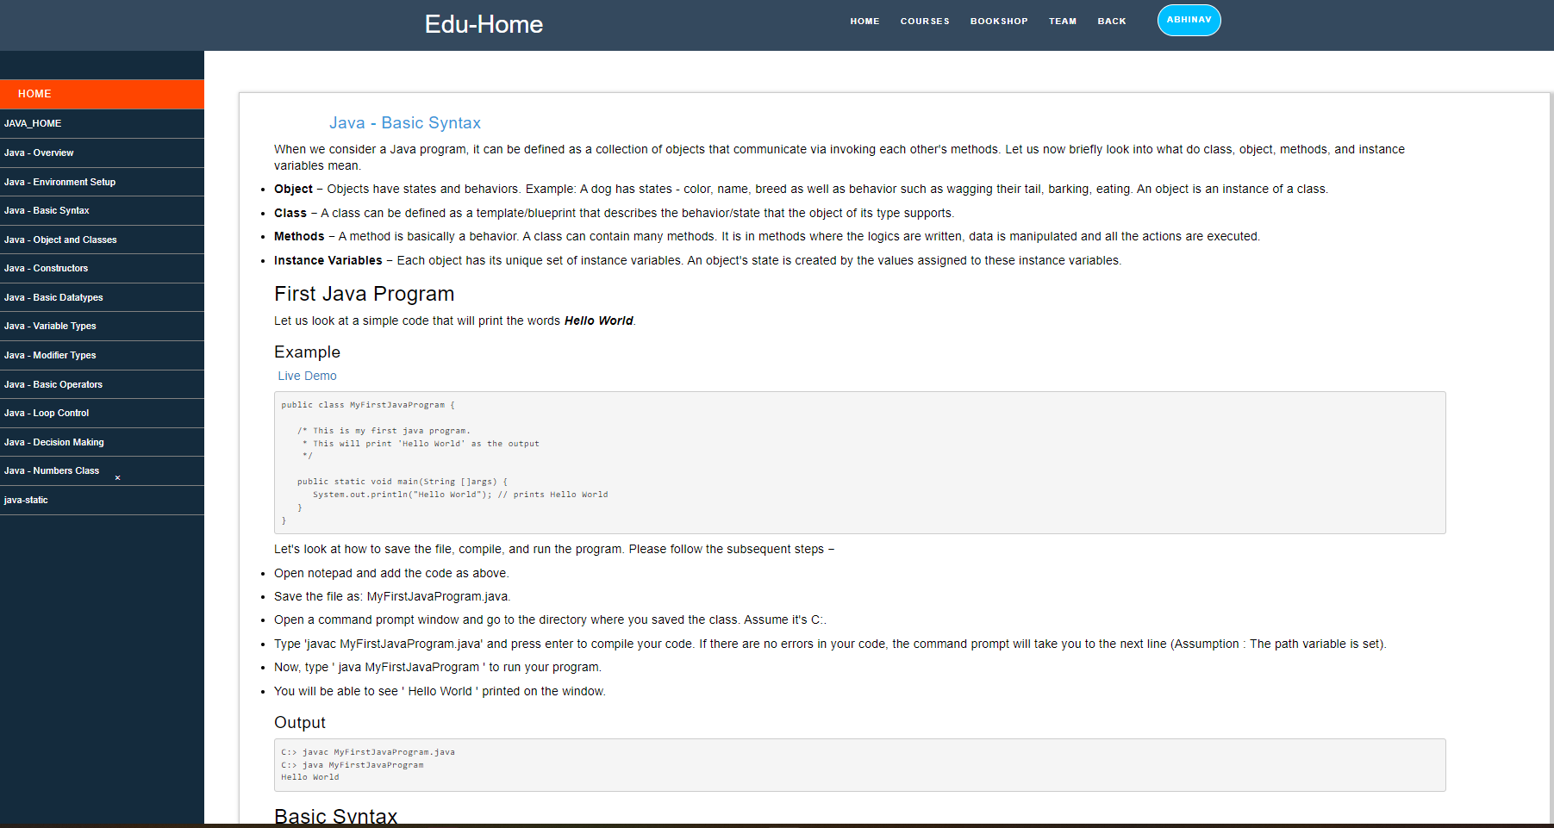

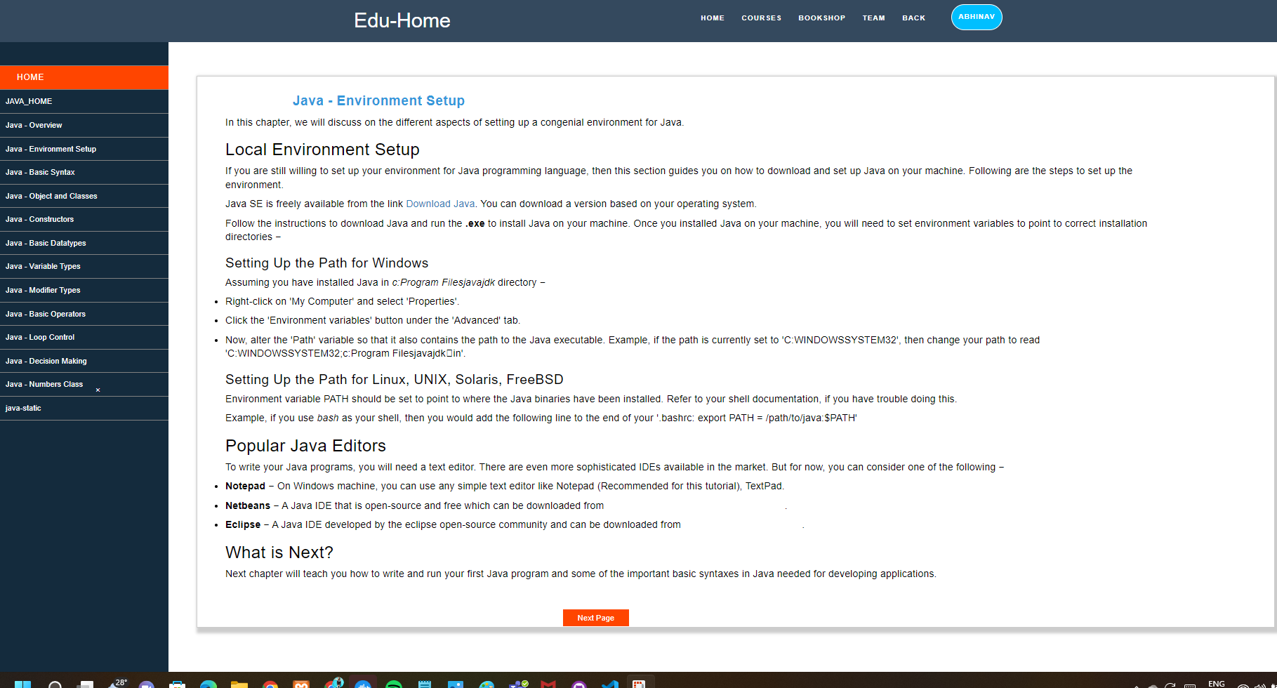

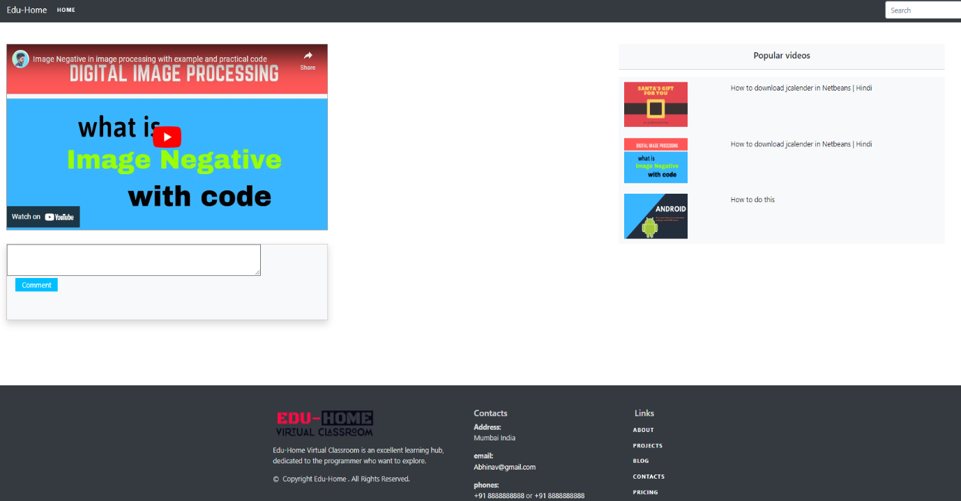

**Exam page:**

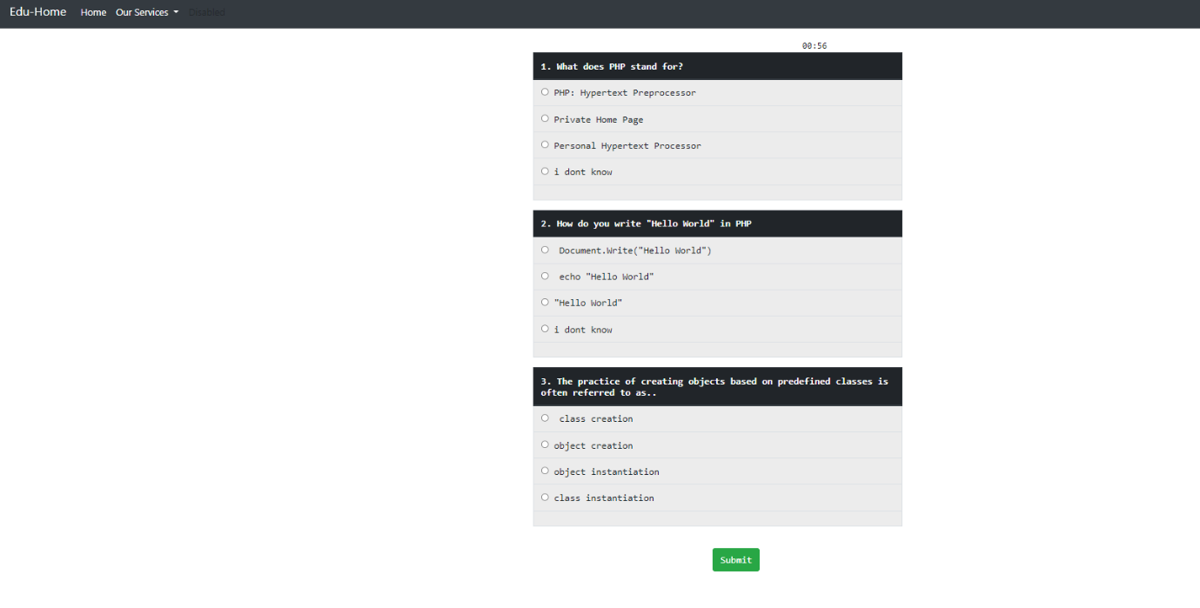

**Admin Account Home Page:**

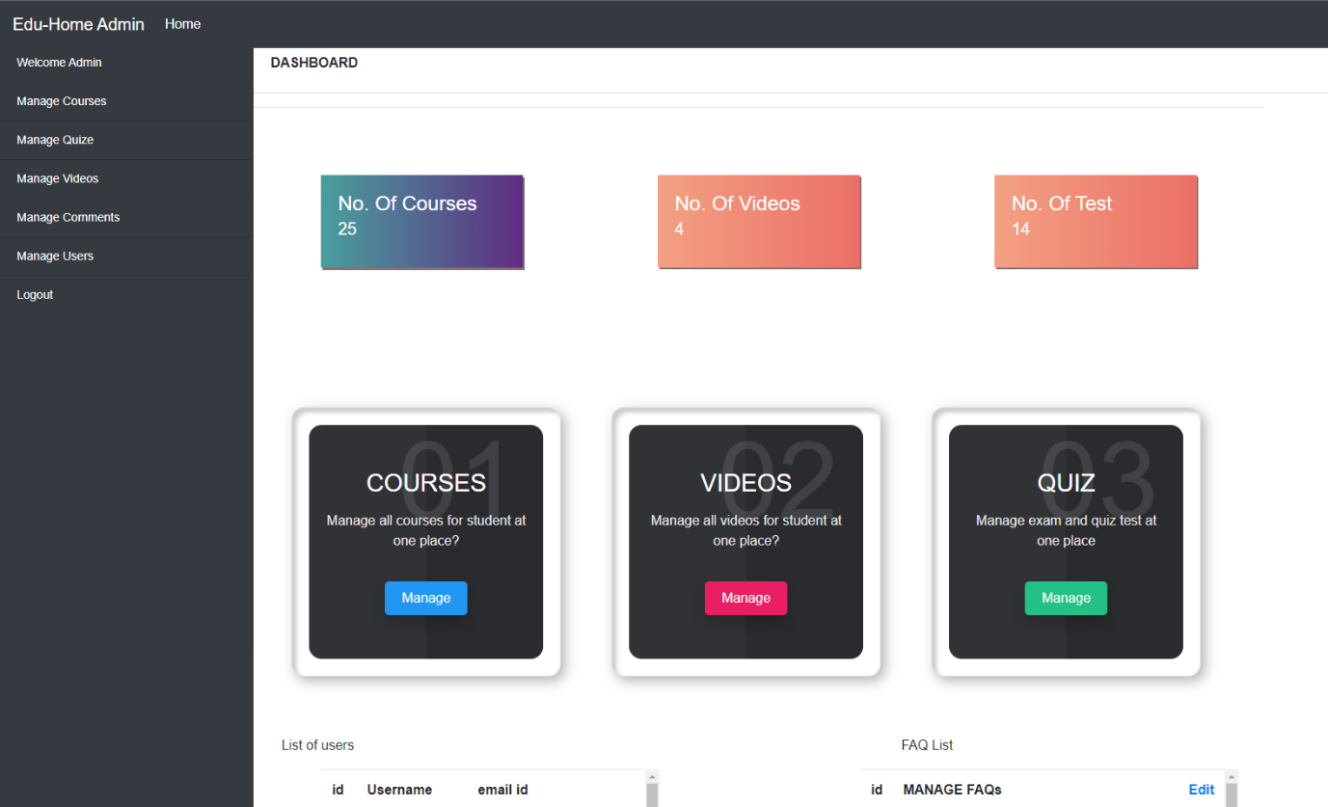

**Adding New Course:**

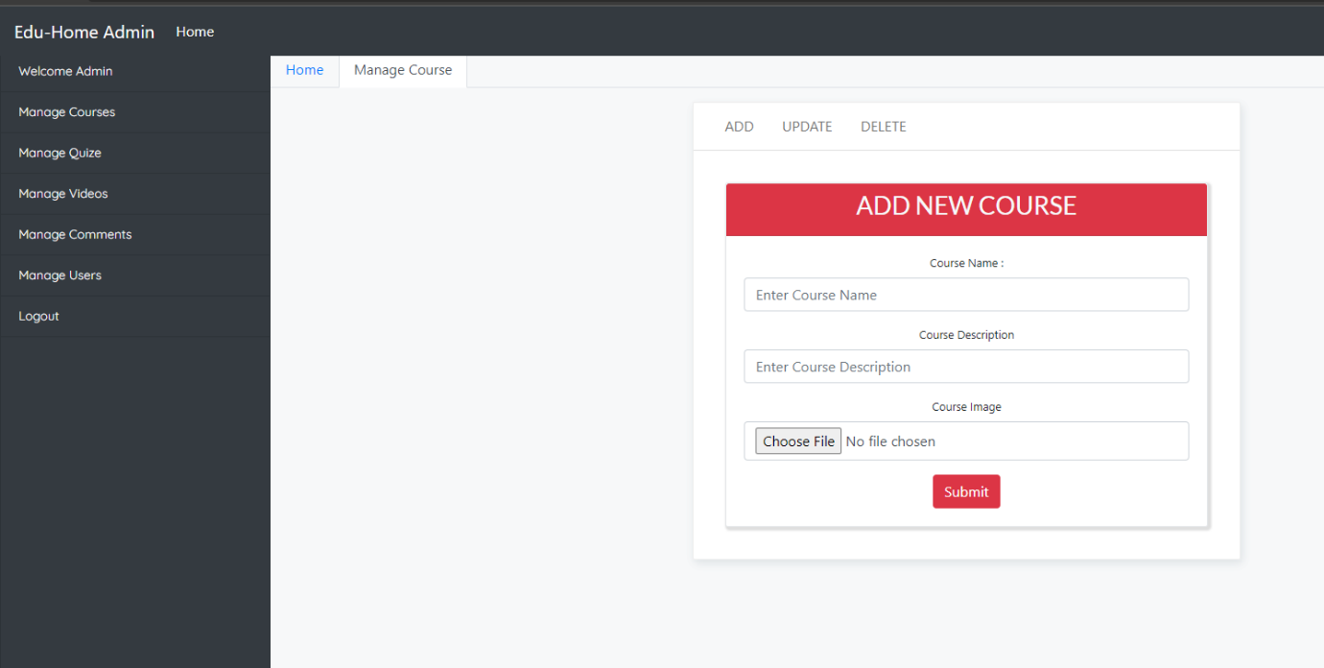

**Adding Videos:**

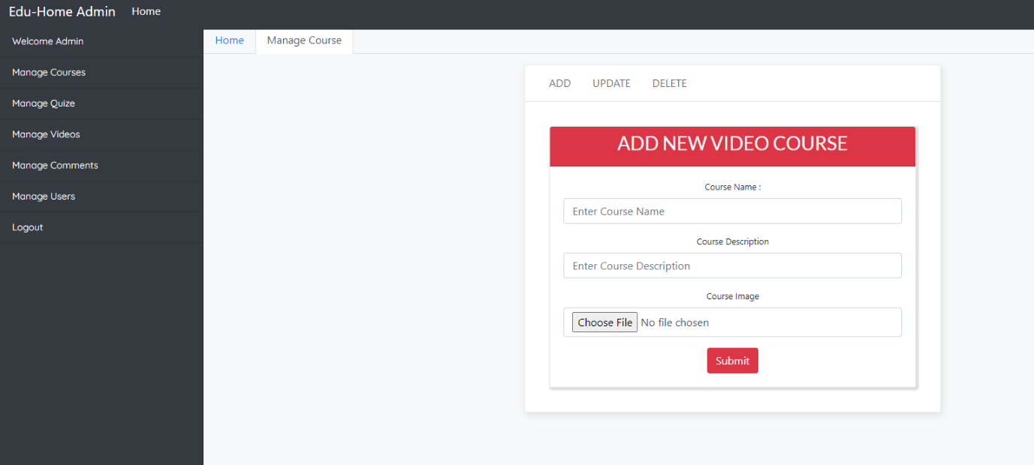

**Adding Questions:**

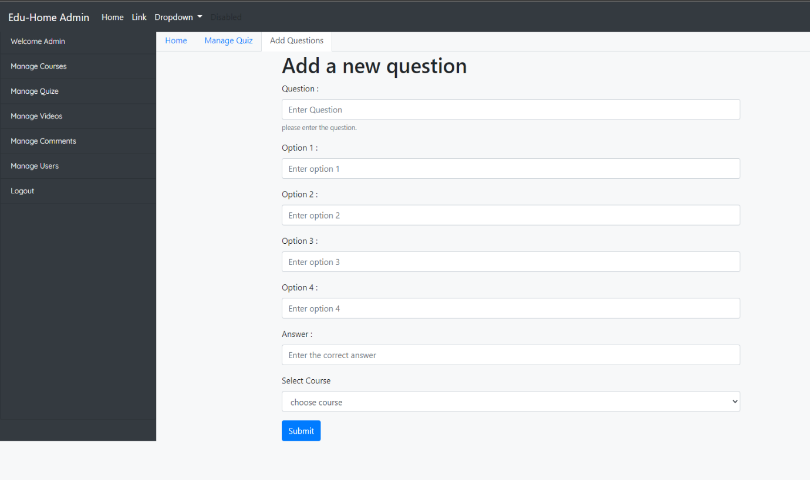

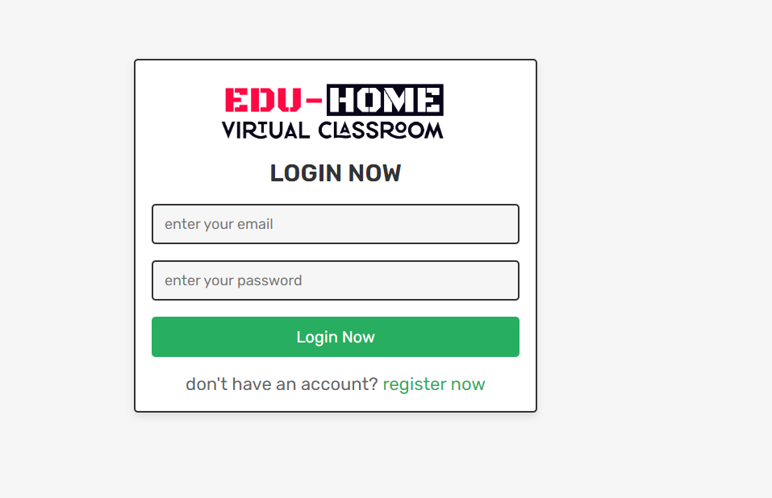



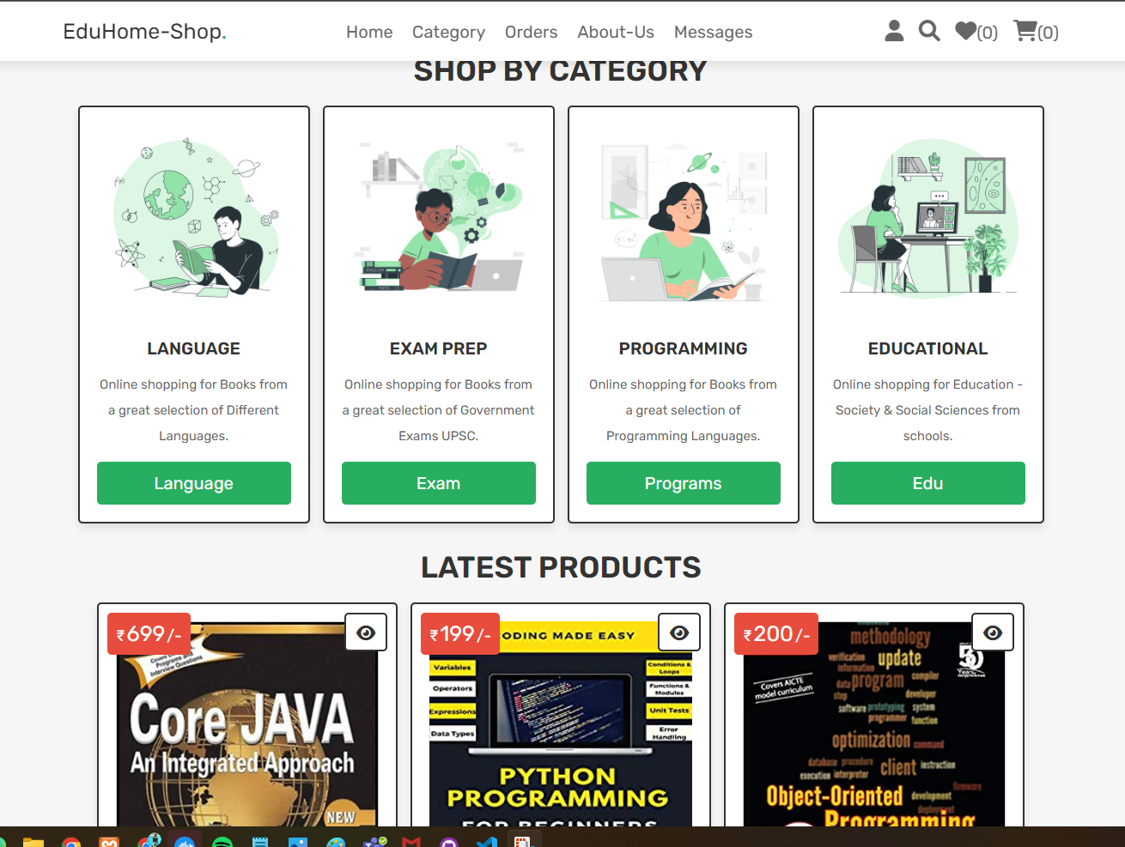

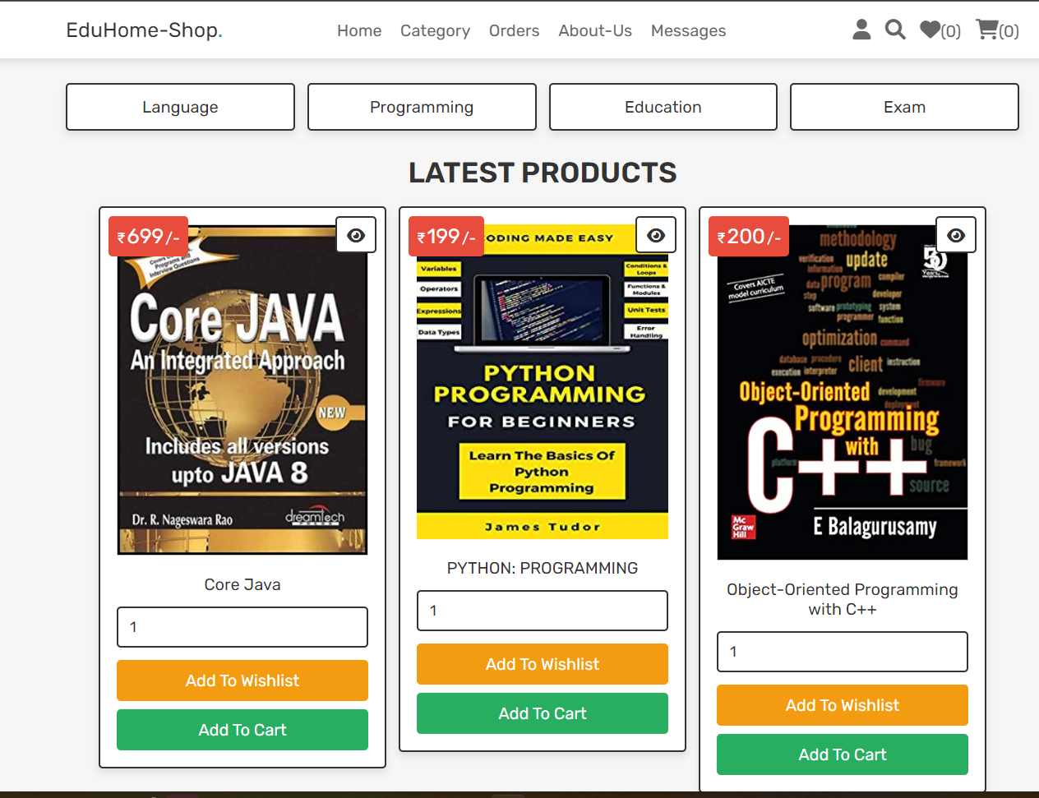

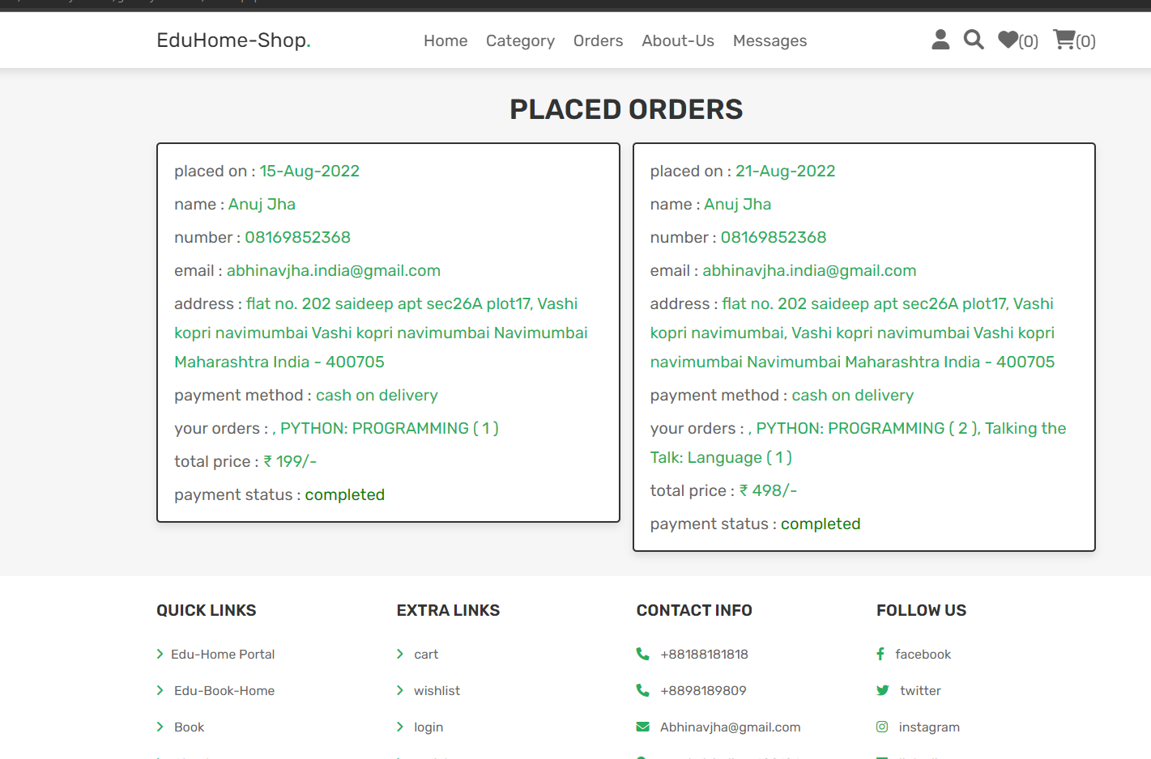

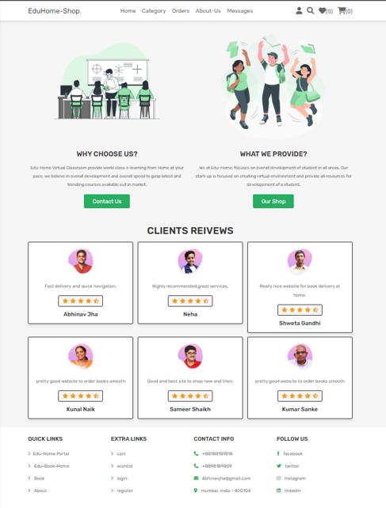

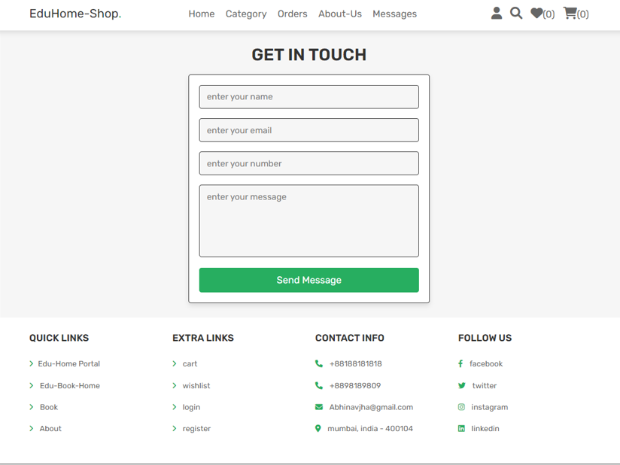

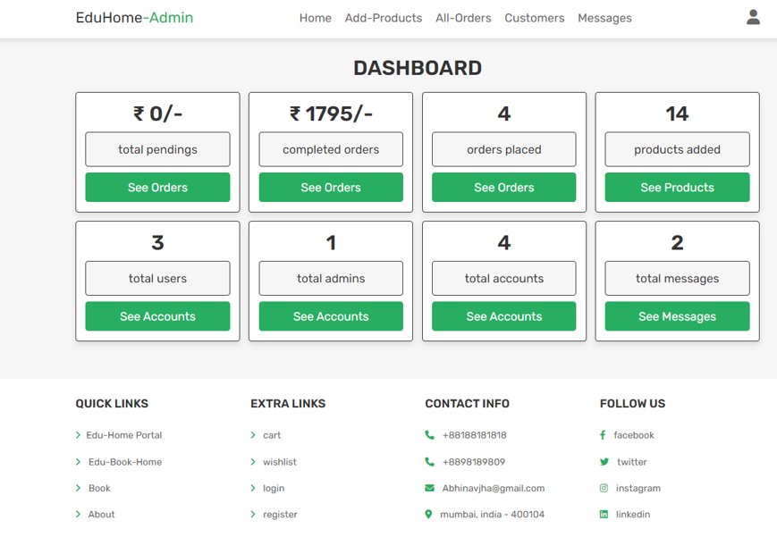

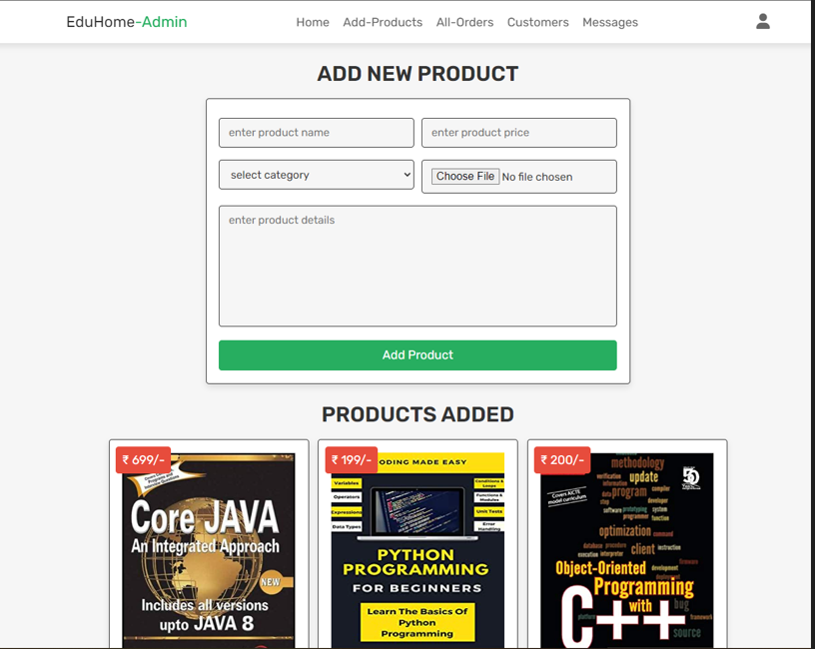

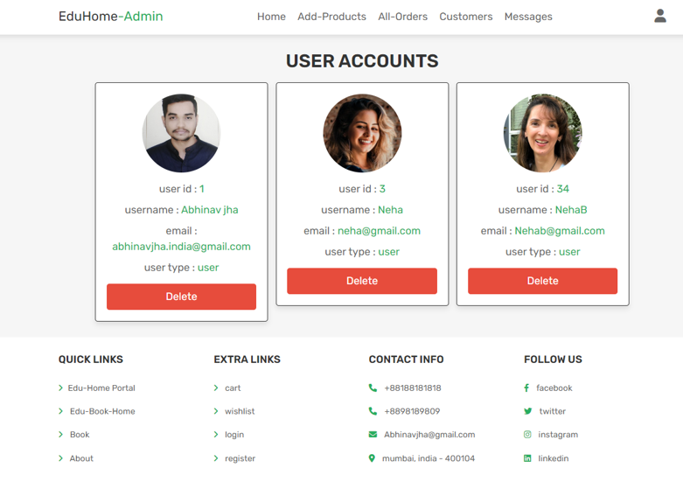

**Testing**

**Testing Considerations**

1. **Vary Your Subjects:**

Find users with varying computing skills and familiarity with the information. Avoid using friends as test users, as they only may compliment your work. You might choose to let users look at the Web site on their own time, but you can learn a lot by watching users interacts with your Web site. Make sure to let them navigate and use the Web site without any outside help from you. Just stand back and watch.

1. **Formalize Your Testing:**

Formalize your testing by creating replicable methods of testing your Web site. Prepare a series of questions that users have to answer after viewing the Web site. Give them a specific task to complete or have them find a particular piece of information. Let them rate the ease of completing such tasks. Compare the results from different users to find any problem areas in navigation. Administer the same testing methods to a variety of users, and watch for trends and consistencies. This lets you compare results or focus on a particular feature of the Web site.

## Test Strategy

A test strategy is an outline that describes the testing approach of the software development cycle. It is created to inform project managers, testers, and developers about some key issues of the testing process.

## Methodologies Adopted for Testing

Following methodologies were used in C for Certification Testing:

## Unit Testing

Unit testing for all the independent modules were tested in isolation. Some modules are tested by writing a separate small program and the outputs were verified.

Example – The subject assing module was tested first by creating a small program that would add subjects and on the success of that program the subject adding module was included in the project. Also there are other such modules which were tested separately before their actual use.

## Integration Testing

The modules which were tested in isolated environment in unit testing were put together for integration testing. In the system, most of the module work together for data manipulation.

Example – The Database module is used in all other main classes for communication with the database. Also testing has been done for inter page data transfer, as data between pages are transferred using session object.

## System Testing

After integration of different modules and pages the entire system is put for testing. Both White Box and Black Box testing have been performed to test the stability of the system and error handling.

White Box testing the known input validation has been checked and the errors if any were fixed as per the requirement.

In Black Box testing the actual site is allowed to access by n number of users and the system is tested for all invalid inputs from the user and the validation of such inputs is taken into considerations. System crash scenarios were also tested.

Also, as the system is a website all hacking testing has been done to avoid any unauthorized access to the system. There are many techniques using which the site can be hacked.

## Performance Testing

The websites performance is very important as it will be used for the management purpose. So, the response of the website for each task should be as quick as possible even on the slow internet connection. All this has been taken care as the site downloads only one certificate once when the user passed in exam and then it uses it again and again from the cache. This improves page loading performance.

Performance at the server side should also be considered as the server has to serve many requests. Also, lots of database query processing degrades the performance.

To tackle this problem the duplicate or same type of database queries are minimized by saving them temporarily in the memory. Also, all the unnecessary data that uses the memory are freed as soon as their usage is over.

Also, threading has been used using delegates for sending email so that the client does not has to wait for the time the email takes to contact to the server and then send the email.

## Test Cases

|  |  |  |  |  |  |  |  |
| --- | --- | --- | --- | --- | --- | --- | --- |
| **Test ID** | **Test Description n** | **Module/ Input** | **Pre- condition** | **Test steps** | **Expected output** | **Actual output** | **Re- mark** |
| T1 | To check the login functionality | Login  Username  : john  Password: 123456 | Login Page should open. | Enter username & password & click on login button | User should Log on to their Login ID | User logged in. | Pass |
|  |  | Username  : john  Password: 1234 |  | Enter wrong username & password & click on login button | Invalid user Message should display. | Invalid message prompt ed. | Pass |
|  |  |  |  | Click on login button | Ask for fill login details | Ask for fill login details | Pass |

|  |  |  |  |  |  |  |  |
| --- | --- | --- | --- | --- | --- | --- | --- |
| **Test ID** | **Test Description** | **Module/ Input** | **Pre- condition** | **Test steps** | **Expected output** | **Actual output** | **Re- mark** |
| T2 | To check the registration functionality | Registration  Name  : enter name  EmailID: Enter valid emailId  Password: Enter password  Re-enter Password:  Enter same password which entered before | Registration page should open. | Enter appropriate data & click on submit | Display Message saying successfully registered. | Display ed Message saying successfully register ed. | Pass |
|  |  |  |  | Enter correct details with wrong Re-enter password field & click on submit | It should prompt for password don’t match. | Getting prompt for password don’t match. | Pass |
|  |  |  |  | Enter correct details with once used EmailID & click on submit | Display message as EmailID already registered has an account. | Display ed message as EmailID already register ed has an account | Pass |
|  |  |  |  | Click on submit | Asking for fill the details | Ask for fill the details. | Pass |

|  |  |  |  |  |  |  |  |
| --- | --- | --- | --- | --- | --- | --- | --- |
| **Test ID** | **Test Descriptio n** | **Module/ Input** | **Pre- condition** | **Test steps** | **Expected output** | **Actual output** | **Re- mark** |
| T3 | To check the exam appearance functional ty | Give Test  Course: select course you wish to give test | Give test page should open. | Click on finish test & if pass then again try to appear for same test | Pass user can reappear for same exam so show test window. | Show test window for same test. | Pass |
|  |  | Start test and select appropriate answer |  |  |  |  |  |
|  |  |  |  | Click on finish test & if fail then again try to appear for same test | Failed User can reappear for same exam. | Show test window for same test. | Pass |
|  |  |  |  |

|  |  |  |  |  |  |  |  |
| --- | --- | --- | --- | --- | --- | --- | --- |
| **Test ID** | **Test Description** | **Module/ Input** | **Pre- condition** | **Test steps** | **Expected output** | **Actual output** | **Re- mark** |
| T4 | To check the login functionality | Login  Username  : admin  Password: 123456 | Login Page should open. | Enter username & password & click on login button | Admin should Log on to their Login ID | Admin logged in. | Pass |
|  |  | Username  : admin  Password: 202909 |  | Enter wrong username & password & click on login button | Invalid user Message should display. | Invalid user Message prompt ed. | Pass |
|  |  |  |  | Click on login button | Ask for fill login details | Ask for fill login  details | Pass |

|  |  |  |  |  |  |  |  |
| --- | --- | --- | --- | --- | --- | --- | --- |
| **Test ID** | **Test Description** | **Module/ Input** | **Pre- condition** | **Test steps** | **Expected output** | **Actual output** | **Re- mark** |
| T5 | To check Course insertion functionality | Course name: jQuery  Course Description: jQueryx  Course Image: Add file | Course Page should open. | Enter course name & course description & click on submit button | Display message as successfully added subject. | Display message as successfully added subject. | Pass |
|  |  |  |  | Click on add submit button | Ask for fill all details | Ask for fill all details | Pass |

|  |  |  |  |  |  |  |  |
| --- | --- | --- | --- | --- | --- | --- | --- |
| **Test ID** | **Test Description** | **Module/ Input** | **Pre- condition** | **Test stessps** | **Expected output** | **Actual output** | **Re- mark** |
| T6 | To check question added or not. | Question: Enter question  Option 1: Enter option 1  Option 2: Enter option 2  Option 3: Enter option 3  Option 4: Enter option 4  Answer: give correct answer  Select Course: Choose from dropdown | Question Page should open. | Enter all fields & click on submit button. | Display message successfully question added. | Display message success fully question added. | Pass |
|  |  |  |  | Enter all fields Except dropdown list & click on submit button | Prompt Message ‘Please select an item from list’ | Prompt ed Message ‘Please select an item from list’. | Pass |
|  |  |  |  | Click on submit button | Ask for fill all details | Ask for fill all details | Pass |

**Maintenance**

**User Manual**

The administrator user has full control of the system. He is the main personnel who manages overall details. Different options available to the administrator user are:

* + Add Users record
  + Retrieve Users record
  + Add subjects record
  + View, update and delete subjects
  + Add questions to corresponding subjects
  + View, update and delete questions

## FAQS

* + How to retrieve user’s details?
  + How to add users?
  + How to add subjects?
  + How to update or delete or active subjects?
  + How to add questions to corresponding subjects?
  + How to update or delete or active questions?

**Annexure**

## Data dictionary

Table is the data element in the Database which is used to store data. In this project MS SQL is used as the backend database for storing all site data into the tables created. The Tables in the database are named in such a way that they explain their purpose. Also, a column name resembles their usage and explains what type of data would be stored.

**Reference/Biography**

**Templates:** W3layout.com

**Generic Information:** Google.co.in

**Basic help related queries:** w3school.com

**PHP Queries -** [https://www.php](http://www.php.net/).net/